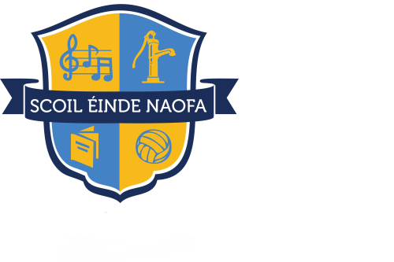

St. Enda’s National School
Lisdoonvarna, Co. Clare.
Roll No.: 19700J
Tel: 065-7074231 Fax: 065-7074231
Website: www.lisdoonvarnans.ie
Email: lisdoonvarnans@gmail.com
Principal: Mr. Brian Carty

Appendix 1: Mainstream Enrolment Application Form 2021-2022
This application form should be filled out in conjunction with the following policy documents: The Admissions Policy, the Code of Behaviour, Data Protection, Internet Acceptable Usage Policy and the Religious Education Policy. These policies are published on our website and a hard copy is available from the office.

Pupil’s First Name:________________________ Surname :________________________
Date of birth: (dd/mm/yyyy)_________________ Gender: M: F:
(Please attach birth certificate – original certificate will be copied and returned)
Address (at which the applicant resides):
__________________________________________________________________________________
__________________________________________________________________________________
Name and class of sibling(s) currently enrolled: ___________________________________________
__________________________________________________________________________________
Parish in which the applicant resides: ___________________________________________________
Parent(s)/Guardian(s) details:
Name: ___________________________________ Parent: Custodian: Legal Guardian Address: __________________________________________________________________________
__________________________________________________________________________________
Home Telephone: _____________________________ Mobile: _____________________________
Parent(s)/Guardian(s) details:
Name: ___________________________________ Parent: Custodian: Legal Guardian Address: __________________________________________________________________________
__________________________________________________________________________________
Home Telephone: _____________________________ Mobile: _____________________________
Form must be returned by: Friday, 26th February 2021
The school will confirm in writing the outcome of the enrolment application by 12th March 2021.
Date application was received: __________

